Task11:
- Window Switch:
package task11;

import java.util.Set;

import org.openqa.selenium.By;
import org.openqa.selenium.WebDriver;
import org.openqa.selenium.chrome.ChromeDriver;

public class SwitchWindow {

public static void main(String[] args) {

WebDriver driver = new ChromeDriver();
driver.manage().window().maximize();
driver.get("https://the-internet.herokuapp.com/windows");
String parentwindow = driver.getWindowHandle();
driver.findElement(By.xpath("//a[text()='Click Here']")).click();

Set <String> allwindows = driver.getWindowHandles();

for(String window : allwindows) {
if(!window.equals(parentwindow)) {
driver.switchTo().window(window);
}
}

String text =driver.findElement(By.tagName("h3")).getText();

if(text.equals("New Window")) {
System.out.println("Text verified Successfully: " +text);
}
else {
System.out.println("Text verification failed: " +text);
}

driver.close();

driver.switchTo().window(parentwindow);

String parenttitle = driver.getTitle();
System.out.println("Back to original page, the title is " +parenttitle);

}

}
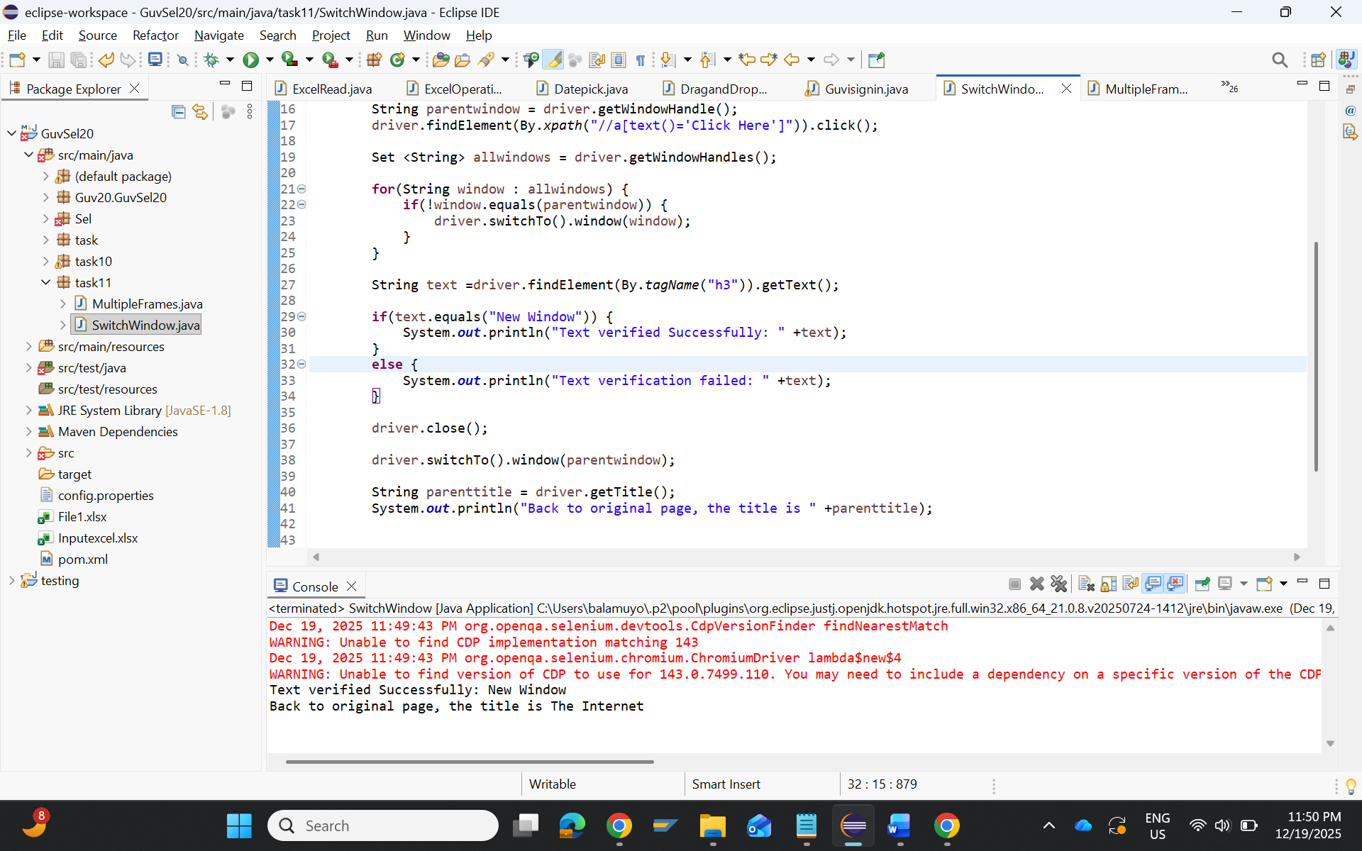
- Frames:
package task11;

import org.openqa.selenium.By;
import org.openqa.selenium.WebDriver;
import org.openqa.selenium.chrome.ChromeDriver;

public class MultipleFrames {

public static void main(String[] args) {
WebDriver driver = new ChromeDriver();
driver.manage().window().maximize();
driver.get("https://the-internet.herokuapp.com/nested_frames");
String pagetitle = driver.getTitle();
System.out.println("the page title is" +pagetitle);

if (pagetitle.equalsIgnoreCase(" ")) {
System.out.println("Title verified: Frames");
} else {
System.out.println("Title verification failed");
}
driver.switchTo().frame("frame-top");

int frameCount = driver.findElements(By.tagName("frame")).size();
if (frameCount == 3) {
System.out.println("Top frame contains 3 frames");
} else {
System.out.println("Frame count mismatch: " + frameCount);
}
driver.switchTo().frame("frame-left");
System.out.println("LEFT frame text: " +
driver.findElement(By.tagName("body")).getText());

driver.switchTo().parentFrame();
driver.switchTo().frame("frame-middle");
System.out.println("MIDDLE frame text: " +
driver.findElement(By.id("content")).getText());

driver.switchTo().parentFrame();
driver.switchTo().frame("frame-right");
System.out.println("RIGHT frame text: " +
driver.findElement(By.tagName("body")).getText());
driver.switchTo().defaultContent();
driver.switchTo().frame("frame-bottom");
System.out.println("BOTTOM frame text: " +
driver.findElement(By.tagName("body")).getText());

driver.quit();

}

}

